Prescribed Focus Areas
Generic scaffold for Prescribed Focus Area (PFA) P4
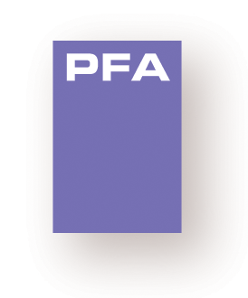
Implications of biology for society and the environment
PFA P4 describes applications of biology which affect
society or the environment
Use the following table to describe an example of an application of biology and its
affect on society and the environment.

Application of biology affecting society and the environment
Example | Historical background | How increases in our understanding in biology have led to the development of useful technologies | Relevance, usefulness and the applicability of biological concepts and principles, and the effect on Australian society and the environment | Ethical implications and contentious issues (financial, medical/health, social justice)

