

Topic test
Name: __________________________________

Logarithmic functions

- Time allowed: 45 minutes
- Part A: 10 multiple-choice questions (10 marks)
- Part B: 9 free-response questions (40 marks)
- Total: 50 marks
Part A
10 multiple-choice questions
1 mark each: 10 marks
Circle the correct answer.

1
A −3 B 3
C D 2
2 log10 (1) =
A 0 B 1
C 2 D 10
3
A a B
C 1 D 2

4 Simplify log4 (x) − log4 (x + 4).
A B
C D −1
5 If logm (12) + logm (x) = 0, then x =
A −12 B 0
C D 1
6 Solve log4 (4x) + 3.
A x = 64 B x = 16
C x = 12 D x = 3
7 Solve 3 log2 (2x − 1) = −9.
A x = B x =
C x = D x =
8 Which function’s graph is the graph of
y = loga (x) translated 3 units upwards?
A y = loga (x + 3) B y = loga (x − 3)
C y = loga (x) − 3 D y = loga (x) + 3
9 What is the equation of this logarithmic graph?
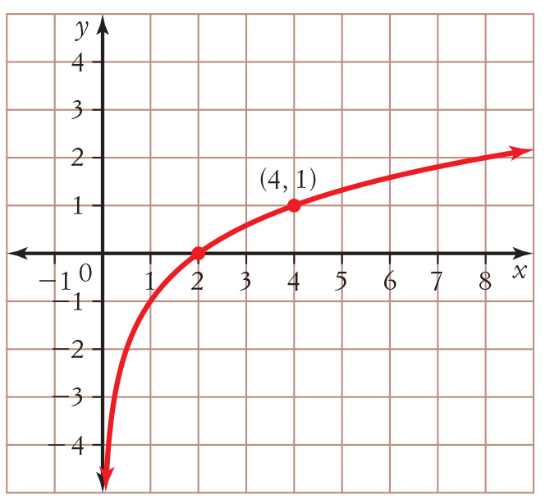
A y = log2 (x − 1) B y = log2 (x) − 1
C y = log2 (x) − 2 D y = log2 (x − 2)

10 The formula for pH is pH = −log[H⁺], where
[H⁺] is the concentration of hydrogen ions, given in mole/litre. If an orange juice has a pH of 3.6, what is the concentration of hydrogen ions?
A –0.5562 B 1.7976
C 0.5563 D 0.0003

Part B
9 free-response questions
40 marks
Show your working where appropriate.
11 Write 34 = 81 as a logarithmic statement.
_________________________________________________________________________________________
[1 mark]
12 Evaluate log7 (35) correct to 4 decimal places.
_________________________________________________________________________________________
[2 marks]
13 Expand loga (xy2) in terms of loga (x) and loga (y).
_________________________________________________________________________________________
_________________________________________________________________________________________
[2 marks]
14 Given that logm (2) = 0.73, logm (3) = 1.15 and logm (5) = 1.68, use the properties of logarithms to evaluate
logm correct to 2 decimal places.
_________________________________________________________________________________________
_________________________________________________________________________________________
_________________________________________________________________________________________
_________________________________________________________________________________________
_________________________________________________________________________________________
[4 marks]
15 Solve each equation.
a log2 (x) = −5
______________________________________________________________________________________
b 2 log3 (3x − 2) = 4
______________________________________________________________________________________
______________________________________________________________________________________
______________________________________________________________________________________
______________________________________________________________________________________

c log (x) + log (x + 3) = log (5x + 8)
______________________________________________________________________________________
______________________________________________________________________________________
______________________________________________________________________________________
______________________________________________________________________________________
d 81 2x⁻ ¹ = 27
______________________________________________________________________________________
______________________________________________________________________________________
______________________________________________________________________________________
______________________________________________________________________________________
______________________________________________________________________________________
e 5 3x ⁻ 4 = 21, correct to 3 decimal places.
______________________________________________________________________________________
______________________________________________________________________________________
______________________________________________________________________________________
[12 marks]
16 On the same number plane below, sketch the graphs of y = log4 (x), y = log4 (x) + 2 and y = log4 (x + 2),
labelling important features.
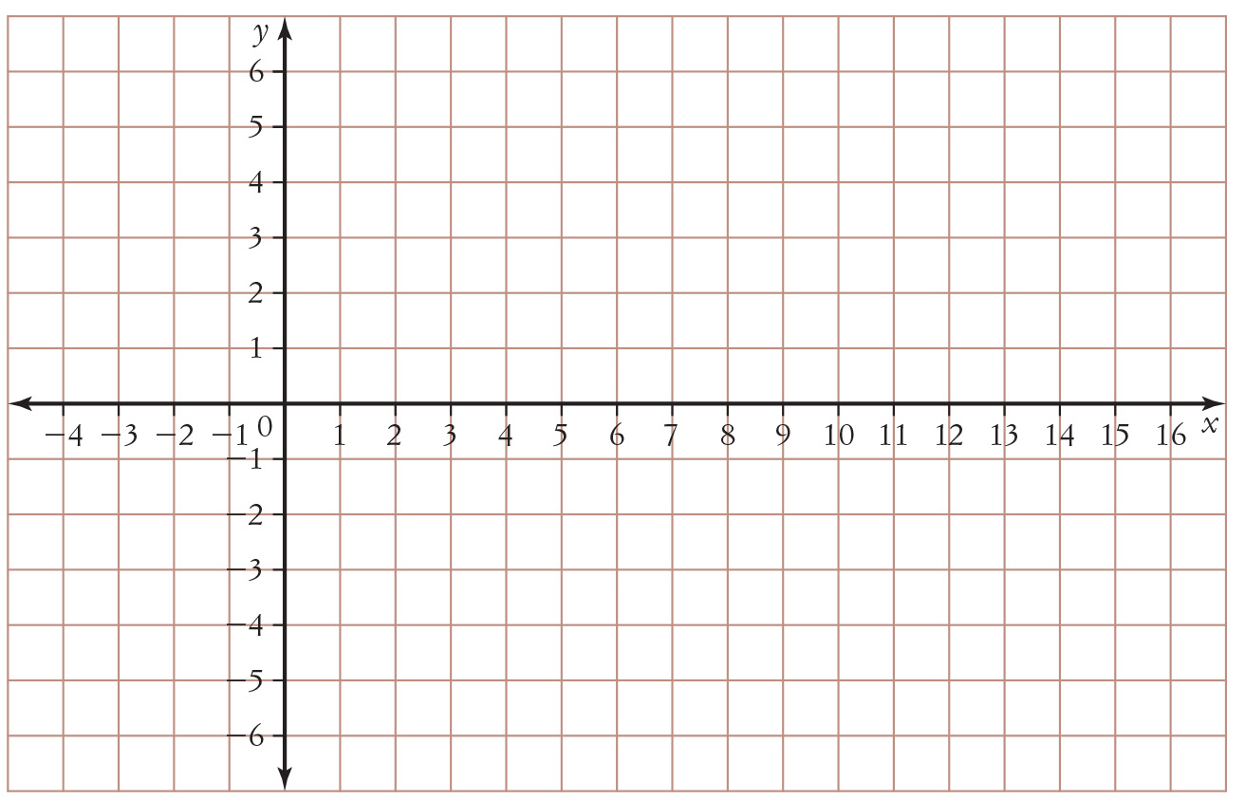
[6 marks]
17 The population of a city can be modelled using the formula P = 4.6(1.08)t, where t is the number of years after 2017 and P is the population in millions.
a Use the formula to calculate the city’s population in the year 2037, to the nearest 100 million.
______________________________________________________________________________________
______________________________________________________________________________________
b In what year will the population be 10 times what it was in 2017?
______________________________________________________________________________________
______________________________________________________________________________________
______________________________________________________________________________________
______________________________________________________________________________________
[4 marks]
18 a If you deposit $6000 into an account paying 4% annual interest compounded monthly, how long will it be until there is $9000 in the account?
______________________________________________________________________________________
______________________________________________________________________________________
______________________________________________________________________________________
______________________________________________________________________________________
b At 3.2% annual interest compounded quarterly, how long will it take to double your money?
______________________________________________________________________________________
______________________________________________________________________________________
______________________________________________________________________________________
______________________________________________________________________________________
[5 marks]
19 One of the Richter formulas used to measure the magnitude, M, of an earthquake is:
M(x) = log
where x is the measure of the amplitude of the earthquake wave and x0 is the amplitude of the standard wave.
a Find the magnitude of an earthquake correct to 2 decimal places if x = 50 000 x0.
______________________________________________________________________________________
______________________________________________________________________________________
______________________________________________________________________________________
______________________________________________________________________________________
______________________________________________________________________________________
b How many times more intense than the reference intensity, x0, is an earthquake with a magnitude of 5.2?
______________________________________________________________________________________
______________________________________________________________________________________
______________________________________________________________________________________
______________________________________________________________________________________
______________________________________________________________________________________
[4 marks]

This is the end of the test.
Use the rest of this page for extra working space.
Answers
Part A
1 A 2 A 3 B 4 C 5 C
6 B 7 A 8 D 9 B 10 D
Part B
11 log3 81 = 4
12 1.8271
13 loga x + 2 loga y
14 −1.05
15 a b c x = −2, 4 d e x = 1.964
16
17 a 21.4 million b year 2047
18 a 121.8 months (just after 10 years) b 87 quarters (21.75 years)
19 a approx. 4.7 b approx. 3 times more: 158 490 x0

